# Using .melt() for stocks vs bond performance - Corrected

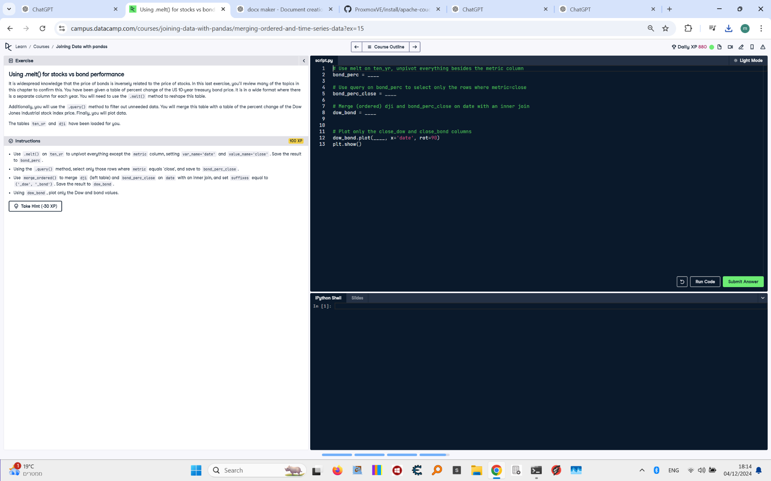

## Question:

It is widely acknowledged that the price of bonds is inversely related to the price of stocks. In this exercise, you'll review many of the topics in this chapter to confirm this. You have been given a table of percent changes of the US 10-year treasury bond price. It is in a wide format where there is a separate column for each metric. You will need to use the .melt() method to reshape this table, filter rows using .query(), and merge it with a table of the percent change of the Dow Jones Industrial stock index price. Finally, you will plot the data.

## Answer:

# Use melt on ten_yr, unpivot everything besides the metric column  
bond_perc = ten_yr.melt(  
 id_vars='metric',  
 var_name='date',  
 value_name='close'  
)  
  
# Use query on bond_perc to select only the rows where metric=close  
bond_perc_close = bond_perc.query('metric == "close"')  
  
# Merge (ordered) dji and bond_perc_close on date with an inner join  
dow_bond = pd.merge_ordered(  
 dji, bond_perc_close,  
 on='date',  
 suffixes=('_dow', '_bond'),  
 how='inner' # Make sure to specify the join type  
)  
  
# Plot only the close_dow and close_bond columns  
dow_bond.plot(  
 y=['close_dow', 'close_bond'],  
 x='date',  
 rot=90  
)  
plt.show()